ℹ️ Instructions

Final Project Scenario Reminder:
You're a Sr. PM in FlowFast's "AI Prototyping Guild," tasked with helping the Consumer & Wellness Division solve high churn. Their fitness app's static, one-size-fits-all plans fail to adapt to user needs. Your ultimate goal is to build a high-fidelity prototype of the "AI Fitness Companion" that simulates a personalized, adaptive experience (such as daily plans and goal setting) to secure executive buy-in before committing engineering resources.

Recap:
In Module 3, your group authored the complete prototyping requirements for this app. In this lab, you will apply the build process we just discussed. Your task is to identify the next logical screen in your user flow (e.g., the "Daily Plan" screen) and break down and unpack those requirements into a new, detailed prompt to generate this next component of your prototype in Lovable.
How this lab connects to your final project:
The screenshots of the feature you generate today will be a core component of your final project deck and include your build insights, while the gaps and bugs you identify (and fix in the second part of the lab) and your analysis will inform your final presentation.
💡 Note on Scope: You are not expected to build the entire app in this course; however, this lab provides the perfect opportunity to practice continuous flow extension. Your goal is to build and link the maximum number of key screens required to complete your core user journey. If you have the credits and a Pro Account, try to go as far as you can! Iterating further on your own is highly encouraged to maximize the value of your final prototype, but it is not mandatory and will not impact the project evaluation of the required components.

Additional Documents to support you (if you missed them):
- AI Prototyping: Final Project Brief: Find more details about your scenario here.
- AI Prototyping Final Project Deliverables Template: When your second feature is finalized, add screenshots to slide 5. Any insights you have towards the build, iteration, or debugging process can be recorded on slides 7 and 8. If you haven’t yet, download a copy by clicking the “Use Template” button.

M4: Hands-On Lab Walkthrough

Lab 1: Iteratively Extend Your Prototype Build

✍️ Use your completed Simplified PRD (prototyping requirements) from Module 3 to help guide your decisions for this lab.
TASK: In your group, return to your completed Simplified PRD from Module 3. Keep in mind, you already have your initial screen (e.g., the "Goal Setting" screen) from previous practice.
Your primary goal now is to execute the next steps of your PRD's complete user flow. This requires mastering the BUILD Cycle:
- Input (Prompt Creation): Identify the next logical screen in your flow (e.g., the "Daily Plan" screen), and continuously translate those requirements into new, detailed prompts.
- Output (Integration): Generate the new screen, link it to the existing components, and immediately proceed to build the next screen in the sequence.
Your task is to continuously execute this loop, iteratively generating and connecting as many components as possible in Lovable, maximizing your prototype's functional journey.

Step 1: Review Your Requirements and Determine Next Steps.
- Have one member of your group open the completed Simplified PRD from Module 3 and share their screen with the rest of the group.
- Reread the Product Overview, Inputs and Outputs, and User Flow sections. As a group, discuss the full journey and identify 2-3 distinct, modular components or screens that appear immediately after the screen you already built. This exercise helps you see the road ahead.
- After discussing the options, write down all the 2-3 screens identified..
✍️ Write your notes, observations, and the single screen selected for the next build step here

Option 1:
Option 2:
Option 3:

- Based on your PRD's defined flow, select the single, most sequential screen required to advance the user's primary journey.
💡Hint: This must be the screen immediately following the initial one you already built (e.g., if you built the 'Goal Setting' screen, the next step is likely the 'Daily Plan' screen). Prioritize the logical flow continuity as defined in your PRD's 'User Flow' section.
Keep in mind: If you are able to complete a full BUILD cycle, return here and choose the next logical piece to build.

Step 2: Translate Requirements into an Advanced Prompt (BUILD Input)
In Module 3, you learned the PRD → Prompt Pack workflow. Now, you will apply the BUILD Cycle's Input phase by designing a highly effective prompt for the next screen that your group identified in step 1 to build.
This prompt must be advanced: it needs to reference the existing screen and incorporate the specific requirements for the new screen.
- As a group, craft one detailed prompt for Lovable to generate the new screen you just selected. You have three advanced approaches to crafting your prompt for Lovable:
(CHALLENGING!) Approach 1: Manually
If you want to practice breaking down and identifying your requirements while improving your prompt engineering skills, work together to write the prompt from scratch, ensuring all FUDI (Functionality, User Flow, Design, and Interaction) elements are included.
✍️ Write your prompt here

Approach 2: AI Meta-Prompting
Head to your AI tool of choice (ChatGPT, Gemini, Claude, etc.) and use a meta-prompt (like the one from Module 3) to generate a high-quality, structured prompt specifically for Lovable, based on your PRD details.

✍️ Paste your prompt here

(OUR RECOMMENDATION!) Approach 3: Hybrid
Use the table below (Column 3) to structure your requirements, and then ask an AI tool (or manually consolidate) the details into a single, high-density prompt. If you are building the 'Daily Plan' screen, you can use the structure of the second (Example Advanced Prompt) column directly.
Simplified PRD Section | Example Advanced Prompt | Structure (To Personalize)
Project Overview | Act as a Senior PM designing the {DailyPlanScreen} for a mobile fitness app. The flow must continue directly from the {GoalSettingScreen} I previously generated. | Act as a [Role] designing the {[Screen Name]} for [App Name]. The flow must continue directly from the {[Previous Screen Name]} I previously generated.
Inputs and Outputs | Crucially, the content must be personalized based on the user's saved goal: {Weight Loss}. Show three workout cards suitable for this goal. | Crucially, the content must be personalized based on the user's saved choice: {[Data variable from previous screen]}. [Describe how content changes].
Smart Behaviors | Generate the {DailyPlanScreen}. Functionality: Include a 'Mark as Complete' checkbox on each card. Ensure the screen defaults to Today's plan. | Functionality: [Describe interactive elements]. Ensure the screen defaults to [Define Logic/State].
Design/Interaction | Design: Use a clean, card-based layout with a persistent navigation bar linking back to {GoalSettingScreen}. Use your established brand colors. | Design: [Describe look and feel]. Ensure navigation links back to {[Previous Screen Name]}.

🆘 SOS: Need Assistance?
If your group is stuck translating the requirements into a working prompt, here are two example approaches for building the "Daily Plan" screen to set you up for success::
Option 1: Direct Prompt (Quick Win)
Use this option if you need to generate a screen immediately to get the lab moving, sacrificing some long-term accuracy.
Generate a "Daily Plan" screen for a mobile fitness app using React and Tailwind. Design: Use a modern, motivational card layout. Functionality: Display 3 workout cards (e.g., "Cardio Blast") and 1 motivational quote. Interaction: Each workout card must have a 'Mark as Complete' checkbox and the screen must link back to the 'Goal Setting' screen. Smart Behavior: The workouts should be mocked up for a user whose goal is 'Weight Loss'.
Option 2: Meta-Prompt (Higher Quality/Precision)
Use this option if you want to leverage AI to refine the prompt structure and ensure better quality before generating in Lovable.
You are helping me write a single, detailed prompt for an AI prototyping tool called Lovable. Goal: Build the "Daily Plan" screen for my Fitness Companion App. Use the FUDI framework and details from my PRD:

Functionality: Display 3 personalized workout cards (e.g., "Cardio Blast") and 1 motivational quote.
User Flow: This screen appears after the 'Goal Setting' screen, and the content must be personalized based on the user's previously set goal.
Design: Use a modern, motivational card-based layout with React & Tailwind.
Interaction: Each workout card must have a 'Mark as Complete' checkbox.
Write one single, natural-language prompt for me to paste into Lovable.

Step 3: Generate the Component and Link the Flow
(BUILD Output)
This is the execution step where you create the next piece of your prototype flow. Return to Lovable and access your project. You can find it from the main screen dashboard by scrolling to the bottom of the page and selecting the right prototype
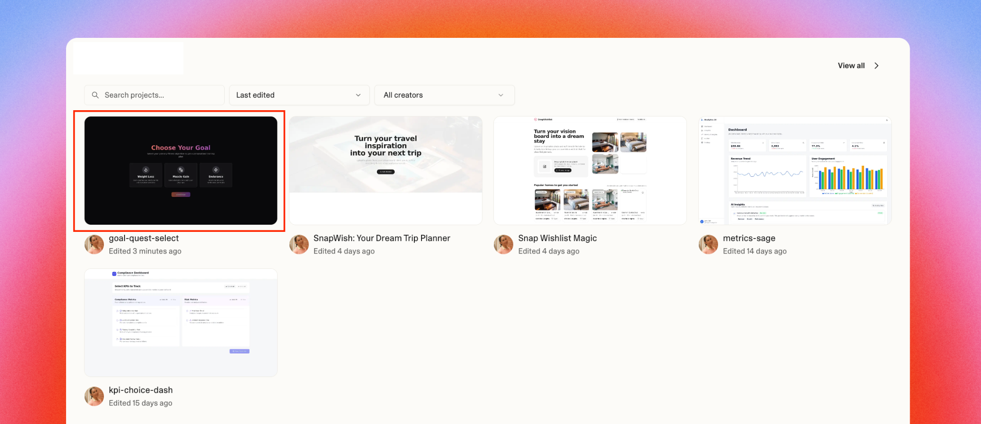

- Have the same group member who shared their screen in the Module 2 lab share again (as they likely have access to the project).
You can also let another member practice by clicking the “Share” button while in the project (top right corner) and either adding their emails or adapting the link so that anyone with the link can edit
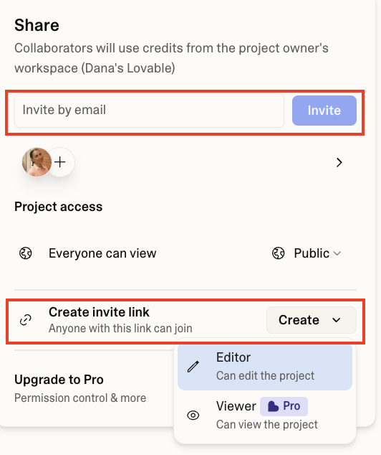
- Paste your carefully crafted prompt to generate your second screen to your prototype.
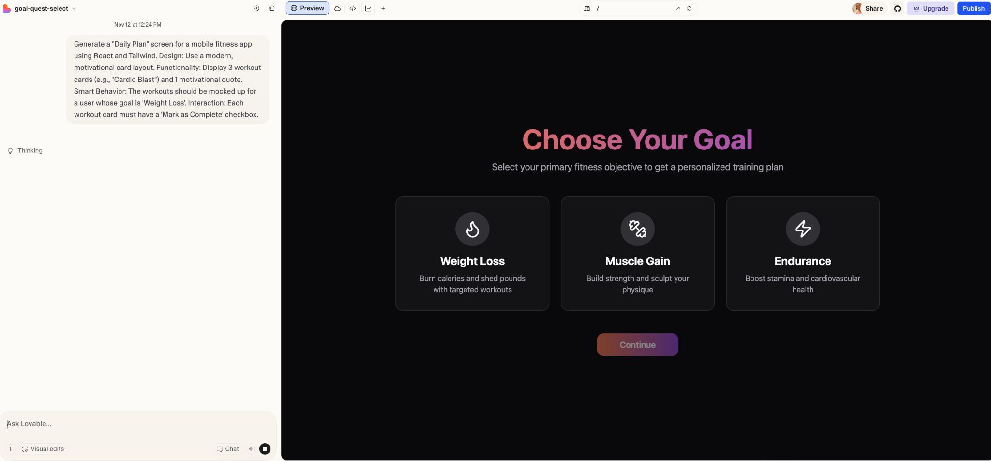
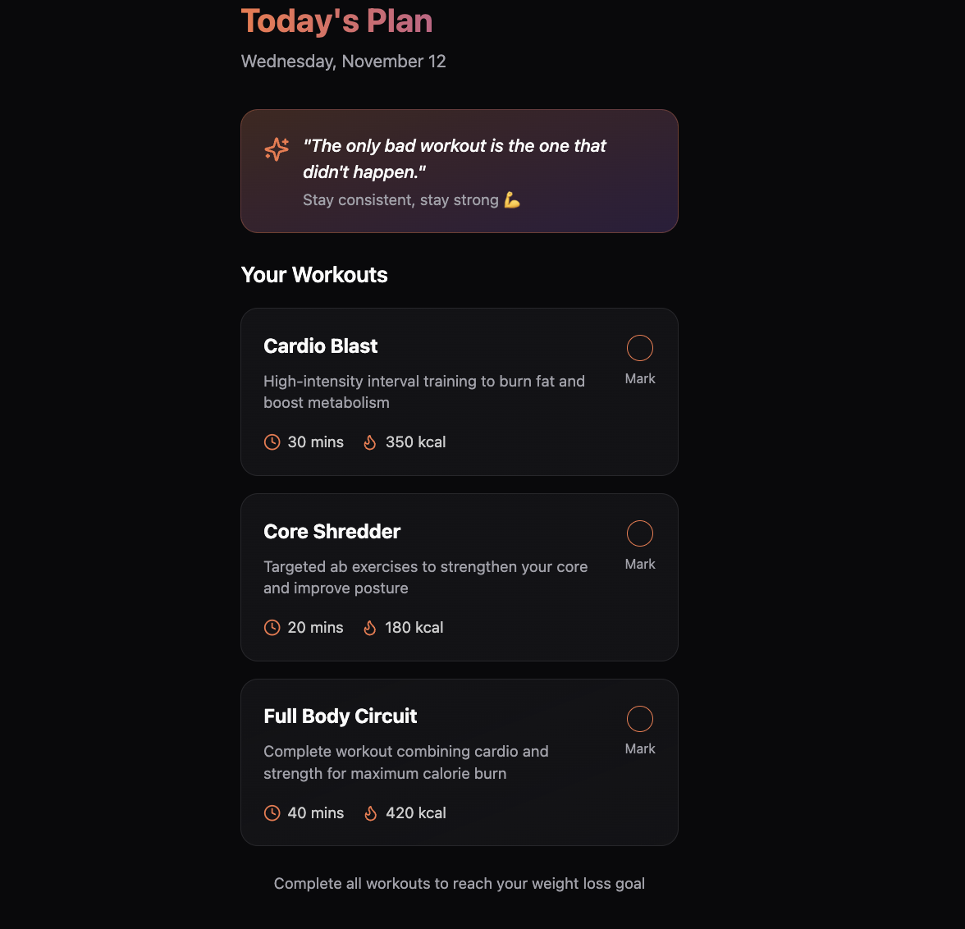

Step 4: Log Your Results
Observe the output as a group. Does it generally match the requirements you specified? Are there any pieces that are missing which disrupt the:
  - Functionality?
  - User Flow?
  - Design?
  - Interactions?
- Identify 1-2 obvious gaps or bugs and write them in the box below. Don’t worry! We will return to them shortly - do not attempt to fix them yet.
- E.g., "The 'Mark as Complete' button doesn't do anything,
- E.g., There is no 'Back' button to return to the Goal Setting screen
- E.g., The layout is confusing
- E.g., It didn’t match our brand guidelines, etc.

✍️ Write your observations here

(Optional) Step 5: Continuous Flow Check
If you have time remaining in the build phase, immediately return to Step 1 and select the next sequential screen to continue extending your prototype flow. Repeat the process!

Step 6: Take a Screenshot
Add screenshots of your current prototype below. You will be able to add them to your final project deliverables deck as part of your final project (if you want to compare the first output to the later version).

📸 Add a screenshot of your VI here

Lab 2: Link and Debug Your Prototype Screens
TASK: In your group, return to your prototype and the list of bugs you identified. Your goal is to apply the Four Core Debugging Strategies (Reflection, Batching, Specification, and Version Control) that you have just learned. You will first plan your fix by filling out the Debug Log template, and then execute your fix using targeted refinement prompts in Lovable.

Step 1: Plan Your Fix in the Debug Log
(Observe → Label → Locate)
- In your group, review your list of fixes you identified in Step 4 (Log Your Results) from the earlier BUILD lab.
For easier access, feel free to paste them here again:
✍️ Copy your observations from Lab 1 here

- Start by choosing one observation you want to tackle first (what is the P0 bug stopping the flow or experience) (bug-related, iteration, things to fix), complete the four sections of the log:
  - Identify the Bug: Observe and describe the symptom.
  - Diagnose: Determine its Priority (Critical or not), Symptom type (e.g., Logical Error, Broken Component, API Error, Integration Error), and Root Cause (e.g., specification/generation).
  - Plan Your Strategy: Choose which of the 4 strategies (e.g., Reflection, Batching, Context Injection, Version Control) is best for this fix.
  - Craft Your Refinement Prompt: Write the exact "fix-it" prompt you will use in Lovable.
  - You can use your own prompt engineering skills or utilize prompting strategies with AI, such as reflection or meta-prompting, to review your previous prompt (which left gaps) and make refinements that aim to meet your new goals and address the issues.
Note: There is space to add more than one bug; just start with one!
Debugging Log

Bug/Gap #1
- Identify the bug and log the issue.
✍️ Log your bug here, or add a screenshot
- Diagnose
- Priority: Is this a critical user flow-blocker? Choose one
- Symptom: Is this a Logical Flaw (AI misunderstood intent) or Broken Component (AI generated bad UI/code)? Choose One
- Root Cause: Is this a Specification Error (I forgot it in the prompt/PRD) or Generation Error (AI failed to build it correctly)? Choose One
✍️ Write your diagnosis here

- Strategy
Which of the four strategies will you use to fix it? e.g., "Specify" to give a more detailed prompt, "Batching" to fix only this component.
Choose here: Choose One

- Craft Your Refinement Prompt
This is the new instruction you'll give the AI. You're not starting over; you're giving a targeted command to fix the bug.

✍️ Write your refined prompt here

Bug/Gap #2
- Identify the bug and log the issue.
✍️ Log your bug here, or add a screenshot
- Diagnose
- Priority: Is this a critical user flow-blocker? Choose one
- Symptom: Is this a Logical Flaw (AI misunderstood intent) or Broken Component (AI generated bad UI/code)? Choose One
- Root Cause: Is this a Specification Error (I forgot it in the prompt/PRD) or Generation Error (AI failed to build it correctly)? Choose One
✍️ Write your diagnosis here

- Strategy
Which of the four strategies will you use to fix it? e.g., "Specify" to give a more detailed prompt, "Batching" to fix only this component.
Choose here: Choose One

- Craft Your Refinement Prompt
This is the new instruction you'll give the AI. You're not starting over; you're giving a targeted command to fix the bug.

✍️ Write your refined prompt here

Step 2: Execute Your Fix in Lovable
- Have one member from your group return to your Lovable project from Lab 1.
Important: To apply best practices (like version control), make sure you copy your last working prompt into your Debug Log or a text file. This ensures you can compare your outputs and refinements.
- Paste your new, refined prompt from your Debug Log and observe the results.
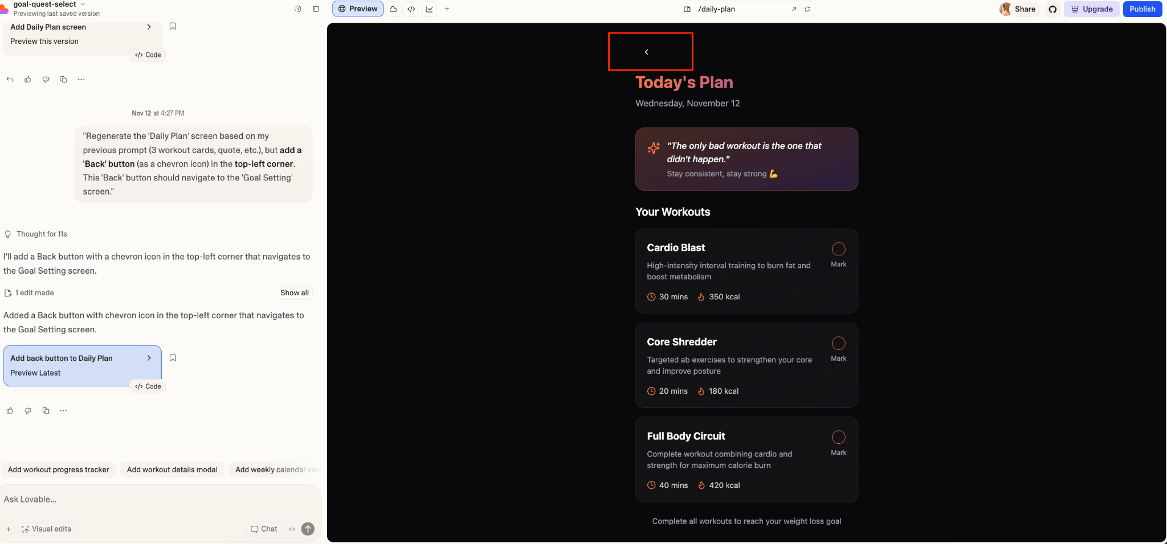

Step 3: Observe, Iterate, and Save
(The Verification Loop)
Review your group’s new regenerated prototype. Did your targeted prompt successfully fix the bug? You have two paths to continue iterating:
- Fix More Bugs
Do you have other bugs in your Debug Log? If yes, repeat the "Plan Your Fix" →"Execute Your Fix" process for the next most crucial bug.
- Build the Next Feature
If your current components are stable, return to your PRD (Source of Truth) and try building the next logical feature from your requirements (e.g., the "Progress Tracking" screen). Repeat the process from Lab 1: Craft a new, detailed prompt for this third feature, generate it, observe the V1, and add any new bugs to your Debug Log.
Note: Be mindful of your Lovable credits!

